+++++++++ Initial Pi Setup +++++++++

1. Setting up localization settings.

a. Change the Pi localization settings to meet your requirements

Start>preferences>Raspberry Pi Configuration>Localization

reboot when finished

2. Update the Pi until the system is at the latest version

reboot when finished

3. Copy nrset folder to pi user desktop

4. Set permissions for the ST.sh file and the settings.js file to allow permissions for anyone

- right click on file properties>permissions

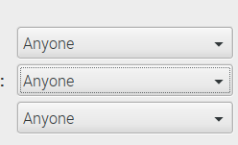

5. Run St1.sh as from the terminal (not as sudo) and accept all the prompts.

/home/pi/desktop/nrset/st.sh

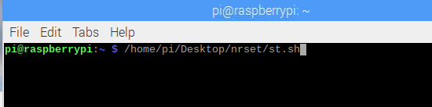

After the script has finished reboot the pi and enter node red from either the pi or a remote web browser by typing **your.ip.here.please:1880** or **localhost:1880** for local pi web access.

Login to node red with the credentials…

User: admin

Password: Noded

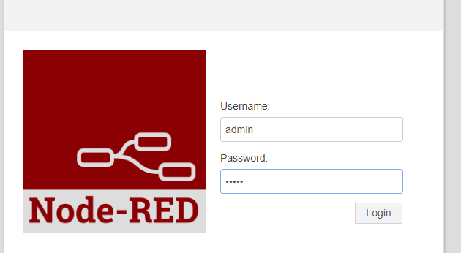

After you have logged into the web page go to settings and manage palette.

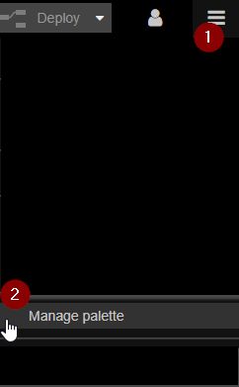

Once you are in the Palette manager navigate to install and copy and paste the below nodes into the search bar to find them. After you find them click install in the lower right hand corner of the node.

**\*\*\* Be sure to leave this screen open as it installs the node. Some nodes can take up to 30 minutes to install!!! ONLY install one at a time!!!\*\*\***

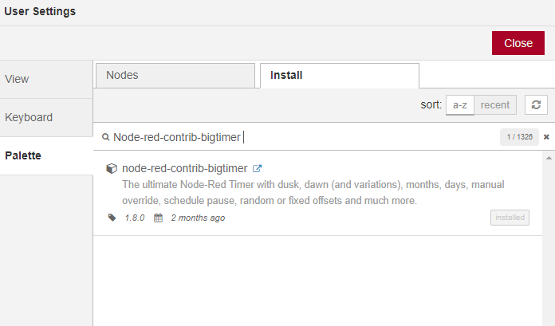

Node-red-contrib-bigtimer

Node-red-dashboard

Node-red-contrib-mqtt-broker

Node-red-contrib-camerapi

Node-red-contrib-usbcamera

Node-red-node-mysql